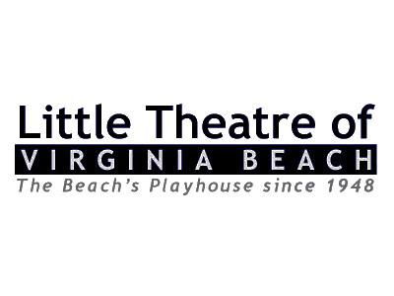
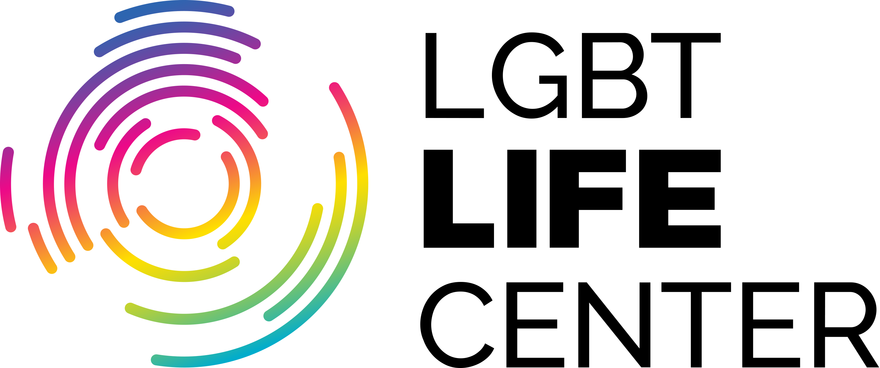
PRESS RELEASE

FOR IMMEDIATE RELEASE: MEDIA CONTACT:
February 11, 2019 Melissa Maniglia
(917) 574-9755
publicity@ltvb.com

The Little Theatre of Virginia Beach, in conjunction with LGBT Life Center, is proud to present master female impersonator Christopher Peterson in his internationally renowned one man show EYECONS, an all live, all fabulous evening bringing to life some of the pop culture’s biggest, and most memorable ladies to the stage.

The Little Theatre of Virginia Beach and t LGBT Life Center are delighted to announce a hilarious evening of Love, Laughter and Liza as Christopher Peterson brings his unsurpassed one man show EYECONS to the LTVB stage on Friday, March 1 and Saturday, March 2, 2019!
This legendary stage performer transforms before your eyes into many of our nation’s most beloved performers including Marilyn Monroe, Reba McEntire, Bette Midler, Cher, Tina Turner, Lucille Ball, Judy Garland, Lady GaGa and, of course, Liza Minnelli!
The theatre opens at 7pm for pre-show cocktails and the show kicks off at 8pm sharp! Afterwards, meet the legend himself, Christopher Peterson, at a post-show Meet and Greet! Tickets are $35 for all seats! Join us for an evening of friends, comedy, and musical merriment that you’ll be raving about for years to come!

“A master of impersonations, both visually and vocally.” -WBOC

“Female impersonators are as much a part of Vegas as slot machines, but Peterson’s master showmanship sets him apart.” -Las Vegas Review Journal

EYECONS runs Friday and Saturday Evenings at 8:00pm, March 1-2, 2019. General Admission tickets are $35. Tickets may be purchased online at www.ltvb.com or you can leave a voicemail for the LTVB box office at (757) 428-9233.

###

About the Little Theatre of Virginia Beach
Celebrating our 71st season, the Little Theatre of Virginia Beach’s mission remains dedicated to educate and provide our community with quality live theatrical experiences at affordable prices, while developing and showcasing local talent. www.ltvb.com

About LGBT Life Center
LGBT Life Center has been empowering the HIV and LGBTQ community of Hampton Roads since 1989. LGBT Life Center is a trusted leader that empowers the LGBTQ communities and all people affected by HIV through improving health and wellness, strengthening families and communities and providing transformative education and advocacy. For more information on LGBT Life Center, please visit www.lgbtlifecenter.org or Corey Mohr at call 757-640-0929.

